PF Lab 9 Tasks

Task 5:

#include <stdio.h>

void swap(int *a, int *b) {
int temp = *a;
*a = *b;
*b = temp;
}

int main() {
int x, y;

printf("Enter first number: ");
scanf("%d", &x);
printf("Enter second number: ");
scanf("%d", &y);

printf("\nBefore swapping:\n");
printf("x = %d, y = %d\n", x, y);

swap(&x, &y);

printf("\nAfter swapping:\n");
printf("x = %d, y = %d\n", x, y);

return 0;
}

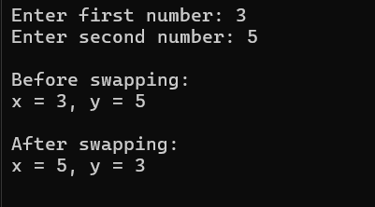

Task 6:

#include <stdio.h>

void calculate(int a, int b, int *sum, float *avg) {
*sum = a + b;
*avg = (float)(*sum) / 2;
}

int main() {
int num1, num2, sum;
float avg;

printf("Enter first number: ");
scanf("%d", &num1);
printf("Enter second number: ");
scanf("%d", &num2);

calculate(num1, num2, &sum, &avg);

printf("\nSum = %d\n", sum);
printf("Average = %.2f\n", avg);

return 0;
}

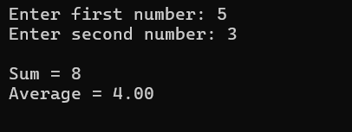

Task 7:

#include <stdio.h>

int main() {
int *ptr = NULL;

if (ptr == NULL) {
printf("The pointer does not reference any valid memory.\n");
} else {
printf("The pointer points to a valid memory location.\n");
}

return 0;
}

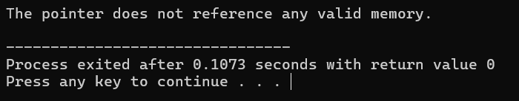

Task 8:

#include <stdio.h>

int main () {

int x = 5;
float y = 23.5;
char z = 'a';

void *ptr;

ptr = &x;
printf("The integer is: %d", *(int *)ptr);

ptr = &y;
printf("\nThe float is: %.2f", *(float *)ptr);

ptr = &z;
printf("\nThe character is: %c", *(char *)ptr);
}

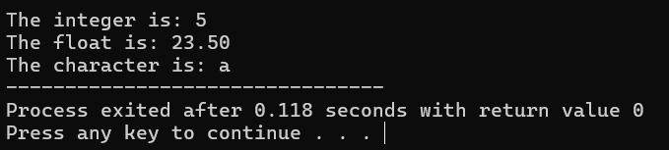

Task 9:

#include <stdio.h>

int add(int a, int b);
int subtract(int a, int b);
int multiply(int a, int b);
int divide(int a, int b);

int add(int a, int b)
{
return (a + b);
}

int subtract(int a, int b)
{
return (a - b);
}

int multiply(int a, int b)
{
return (a * b);
}

int divide(int a, int b)
{
return (a / b);
}

int main () {

int num1, num2, result;
char opp;
int (*operation)(int, int);

printf("Enter first number: ");
scanf("%d", &num1);

printf("\nEnter the operator (a - add / s - subrtract / m - multiply / d - divide): ");
scanf(" %c", &opp);

printf("\nEnter second number: ");
scanf("%d", &num2);

if(opp == 'a')
{
operation = add;
result = operation(num1, num2);
printf("\nThe result is: %d", result);
}
else if(opp == 's')
{
operation = subtract;
result = operation(num1, num2);
printf("\nThe result is: %d", result);
}
else if(opp == 'm')
{
operation = multiply;
result = operation(num1, num2);
printf("\nThe result is: %d", result);
}
else if(opp == 'd')
{
operation = divide;
result = operation(num1, num2);
printf("\nThe result is: %d", result);
}

return 0;
}

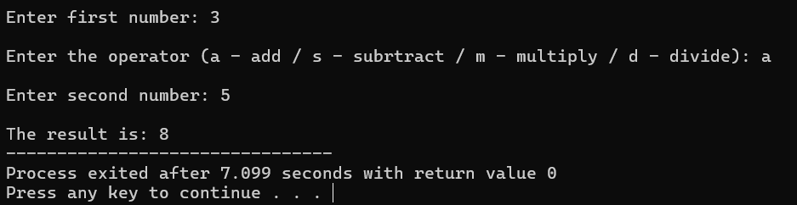

Task 10:

#include <stdio.h>

float average(int a, int b, int c) {
return (a + b + c) / 3.0;
}

int main() {
int x = 10, y = 20, z = 30;
float result;

result = average(x, y, z);

printf("The average of %d, %d, and %d is: %.2f\n", x, y, z, result);

return 0;
}

